

P R O J E C T H A N D B O O K

**Project: Wound Analysis Based On Image Processing**

Course: Information Engineering and Computer Science

Semester: 2

Teacher: Dr. Timo Kahl

Project leader:

Project members: Qurratul Ain Abid (Matriculation no. 21037)

**3. Project Organization**

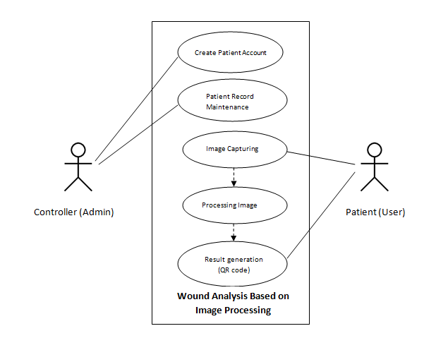 *Fig: Use Case Diagram*

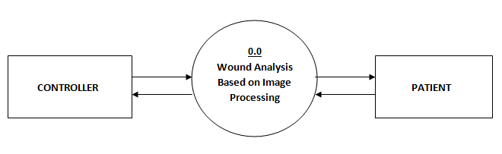 *Fig: Level 0 DFD*

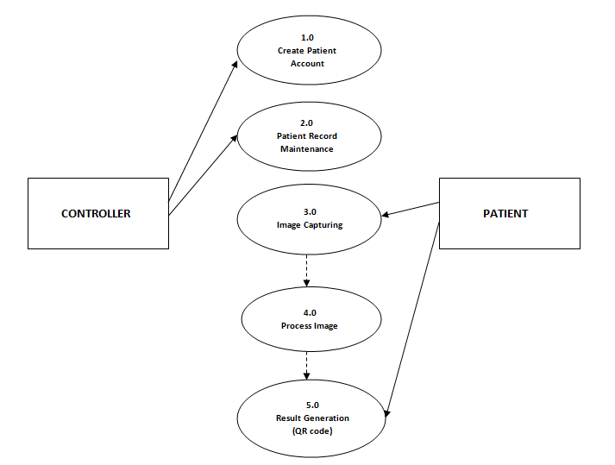

*Fig: Level 1 DFD*



1. **WSP Specification/ Description**

Describe the most important work packages of your WSP.

|  |  |  |
| --- | --- | --- |
|  |  | **WP Specification** |
| **Work Package:** 1.0 Research | |  |
| WP Content / Results: |  |  Research on image processing algorithm, hardware, types of |
|  |  | wound, design and development tools. |
|  |  |  |
| Responsible Person: |  | All group members |
|  |  |  |
| Progress since last status |  | Image processing algorithms research: Anith, Qurratul-Ain and Arun. |
| report: |  | Types of Wound: Mayuri and Jeff. |
|  |  | Hardware: Amir. |
|  |  |  |
| Open issues: |  | <Description> |
|  |  |  |

|  |  |
| --- | --- |
|  | **WP Specification** |
| **Work Package:** 2.0 User Interface Design and Development | |
| WP Content / Results: |  User Interface Design and Coding |
|  |  |
| Responsible Person: | Anith and Amir |
|  |  |
| Progress since last status | <Description> |
| report: |  |
|  |  |
| Open issues: | <Description> |
|  |  |

|  |  |
| --- | --- |
|  | **WP Specification** |
| **Work Package:** 3.0 Image Processing and Hardware Integration | |
| WP Content / Results: |  Implementation of image processing algorithm and hardware. |
|  |  |
| Responsible Person: | Qurratul Ain and Arun |
|  |  |
| Progress since last status | <Description> |
| report: |  |
|  |  |
| Open issues: | <Description> |
|  |  |

|  |  |  |
| --- | --- | --- |
|  | **WP Specification** |  |
| **Work Package:** 4.0 Databases | |  |
| WP Content / Results: |  Database designing and development |  |
|  |  |  |
| Responsible Person: | Jeff and Mayuri |  |
|  |  |  |
| Progress since last status | <Description> |  |
| report: |  |  |
|  |  |  |
| Open issues: | <Description> |  |
|  |  |  |
| IP_Project-Handbook_V001_KN.doc | 05.11.2017 | !8 |



|  |  |
| --- | --- |
|  | **WP Specification** |
| **Work Package:** 5.0 Testing and Deployment | |
| WP Content / Results: |  Testing and Final Deployment |
| Responsible Person: | All group members |
|  |  |
| Progress since last status | <Description> |
| report: |  |
|  |  |
| Open issues: | <Description> |
|  |  |

|  |  |  |
| --- | --- | --- |
| IP_Project-Handbook_V001_KN.doc | 05.11.2017 | !9 |



1. **Project Milestones**



**Milestones**

|  |  |  |  |  |  |  |  |
| --- | --- | --- | --- | --- | --- | --- | --- |
|  | **WSP-Code** | **Milestone-** |  | **PLANNED-DATE** |  | **IS-DATE** |  |
|  | **Name** |  |  |  |
|  |  |  |  |  |  |  |
| 1.0 | Initial Research | Research | 16 | October | 4 November | |  |
|  | |  |  | |  |  |  |
| 2.0 Analysis/Software | | Software Requirement | 4 November | | 14 | November |  |
| Requirements | | Specification |  |  |  |  |  |
|  |  |  |  |  |  |  |  |
| 3.0 | Design | UI Design and Code | 20 | November | 15 | December |  |
|  |  |  |  | |  |  |  |
| 4.0 | Development | Image processing and | 5 December | | 10 | January |  |
| (Phase 1) | | hardware integration |  |  |  |  |  |
|  |  |  |  | |  | |  |
| 4.0 | Development | Databases | 5 December | | 5 January | |  |
| (Phase 2) | |  |  |  |  |  |  |
|  |  |  |  |  |  |  |  |
| 5.0 | Deployment | Deployment and | 12 | January | 24 | January |  |
|  |  | Testing |  |  |  |  |  |
|  |  |  |  |  |  |  |  |

1. **Project Schedule Plan**

|  |  |  |  |
| --- | --- | --- | --- |
| **Task** | **Start Date** | **Days to Complete** | **Task Names as in WBS** |
| T_1.0 | 16-Oct | 18 | Research |
| T_2.0 | 04-Nov | 2 | Analysis/Software Requirements |
| T_2.1 | 06-Nov | 2 | Conduct needs analysis |
| T_2.2 | 10-Nov | 4 | Draft preliminary software specifications |
| T_2.3 | 14-Nov | 4 | Secure required Resources |
| T_3.0 | 20-Nov | 3 | Design |
| T_3.1 | 24-Nov | 6 | Basic Prototype Design |
| T_3.2 | 01-Dec | 6 | Develop functional specifications |
| T_4.0 | 10-Dec | 5 | Development |
| T_4.1 | 16-Dec | 18 | Develop code/Algorithm |
| T_4.2 | 05-Jan | 7 | Hardware Integration |
| T_5.0 | 12-Jan | 6 | Deployment/Testing |
| T_5.1 | 18-Jan | 4 | Testing |
| T_5.2 | 22-Jan | 4 | Determine final deployment strategy |
|  |  |  |  |
|  | Task schedule based on WBS |  |  |

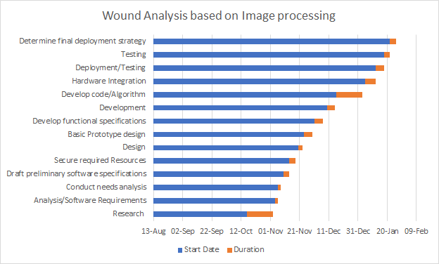

*Fig: Gantt Chart*

1. **Project Costs and Risks**

|  |  |  |
| --- | --- | --- |
| *Work Package / Milestone* | *Type of Costs* | *Amount/Effort* |
| *Name* | *e.g Personal, material* | *e.g 5 hours* |
| **Barcode scanner** | **material** | **15 hours** |
| **camera** | **material** | **5 hours** |
| **Clouding system** | **material** | **15 hours** |

|  |  |  |  |
| --- | --- | --- | --- |
| *Risk* | *Event risk* | *Impact* | *measures* |
| *NAME AND DISCRIPTION* | *e.g in %* | *e.g quality cost date* | *Wbs code name* |
| **Integration of hardware and software** | **20%** | **Barcode scanner** |  |
| **Software specifications** | **20%** | **R coding / phython** |  |
| **Camera of choice** | **10%** | **Digital camera/ msart phone camera** |  |
| **Integration of database to cloud** | **30%** | **Azure/ docker cloud** |  |
| **Accurate image detector** | **20%** |  |  |

|  |  |  |
| --- | --- | --- |
| IP_Project-Handbook_V001_KN.doc | 05.11.2017 | 10! |

**1. Research Topics Detail**

|  |  |  |
| --- | --- | --- |
| 1. | Anith | Research on different types of Image comparison Algorithms |
| 2. | Qurratul Ain | Research on different types of Image comparison Algorithms |
| 3. | Arun | Research on different types of Image comparison Algorithms |
| 4. | Jeff | Searching types of Wounds |
| 5. | Mayuri | Searching types of Wounds |
| 6. | Amir | Research on hardware device for Images |

**2. Task Distribution List**

1. Architecture design.
2. Layering the system.
3. Front end design.
4. Back end design.
5. Algorithm integration.
6. Code testing in R, Python, C#, MAT lab.
7. Wound Image collection for training the system.
8. Hardware integration.
9. Entity search and finalisation.
10. Database SQL server set up and implementation(primary publishing)
11. IBM cloud set up and implementation (secondary publishing)
12. Testing.

|  |  |  |
| --- | --- | --- |
| # | Tasks | Assigned to |
| 1 | Architecture design. | Anith |
| 2 | Layering the system. | Anith |
| 3 | Front end design. | Qurratul Ain |
| 4 | Back end design. | Amir |
| 5 | Algorithm integration methods. | Arun, Qurratul Ain |
| 6 | Image comparison Code testing in R. | Anith |
| 7 | Image comparison Code testing in Python | Arun |
| 8 | Image comparison Code testing in C# | Amir |
| 9 | Image comparison Code testing in MAT lab | Mayuri, Qurratul Ain |
| 10 | Wound Image collection for training the system. | Jeff,Mayuri |
| 11 | Entity search and finalisation. | Qurratul Ain,Arun |
| 12 | Hardware integration. | Amir,Arun |
| 13 | Database sql server set up and implementation(primary publishing) | Anith,Amir |
| 14 | IBM cloud set up and implementation (secondary publishing) | Jeff,Arun |
| 15 | Testing . | Mayuri, Jeff |

**3. Flow chart (Function flow)**

1. **Operator**

Start

End

Send email with rejection reason

Send email with account details

Verify Patient details

View Patient Details

Delete Patient Record

Requested Patient List

Enrolled Patient List

Website Tab 2

Website Tab 1

Operator Login